Autumn Term 1 2026
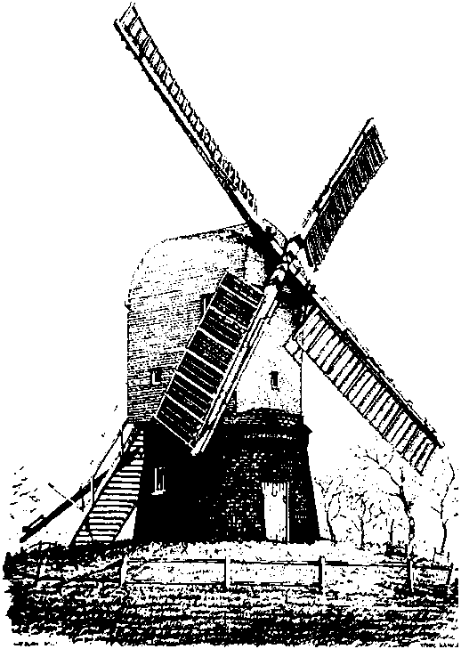
Wrawby St Mary’s C of E Primary School

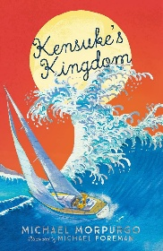
Maths Skills
This half term will be focusing on:
Time: (Y4) Consolidating telling the time on an analogue and digital clock as well as learning how to convert to a 24-hour clock. (Y5) Consolidating previous knowledge of time and solving more complex problems involving time.
Number: (Y4) Find 1000 more or less than a given number, round any number to the nearest 10, 100 or 1000 as well as using addition and subtraction methods on 4-digit numbers. (Y5) Compare, round and order numbers up to 1,000,000 as well as using mental strategies to add and subtract larger numbers.
Fractions: (Y5) Read, write and order numbers with up to 3 decimal places
To help your child spend 5 mins a day chanting the 6, 7 and 9 times tables ahead of the Y4 MTC test in June. Don’t forget to use your TTRockstars account available as an app too – if your password doesn’t work, please let us know.

Our class reading for pleasure book is Kensuke’s Kingdom by Michael Morpurgo. When Michael becomes stranded on a remote island, after being washed overboard from his family yacht, he meets an elderly Japanese man named Kensuke who has lived alone for many years. They learn to trust one another and form a strong friendship while surviving on a deserted island with no sign of help on its way.

,

RE
This half term we will be exploring the questions:

What is religion? What is spirituality?
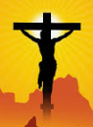
Geography
This half term, we will be exploring how climate change affects the United Kingdom. The children will learn about what climate change is and what is causing these changes. We will then look at how this disrupts the world around us.

ICT
This half term we will apply our knowledge and understanding of networks, to appreciate the internet as a network of networks which need to be kept secure. They will also evaluate online content.

Science
In science, pupils will be learning about forces and how they affect the movement of objects.
They will explore different forces, including push, pull, friction and gravity. We will investigate how these forces can change an objects speed, direction or shape.
The children will make predictions, record results and develop their scientific understanding.

English
Our first piece of writing this half term, will be instructions on how to survive a desert island, inspired by Kensuke’s Kingdom.
After that, we will be writing an extended narrative which will focus on Michael’s feelings of despair during his time stuck on the island.
Our final piece of writing for this half term will be a change of perspective, in which we will write a narrative based around Kensuke and his thoughts and feelings when Michael arrived on the island.

PSHRE
This half-term, we will discuss ideas around belonging and new beginnings.
Art
This half term, the children will be learning how to create abstract self-portraits, influenced by Picasso.

The children will study Picasso’s paintings and discover his ‘cubism’ style of artwork. They will experiment with patterns and shapes to develop their self-portraits to a more abstract piece of art.

PE
This half-term, we will continue athletics skills on Tuesdays with Mr Brown, and we will look at Hoop Ball, a variation on Netball, with Mrs Plange on Wednesdays.

