Spring term 2026 Class 1
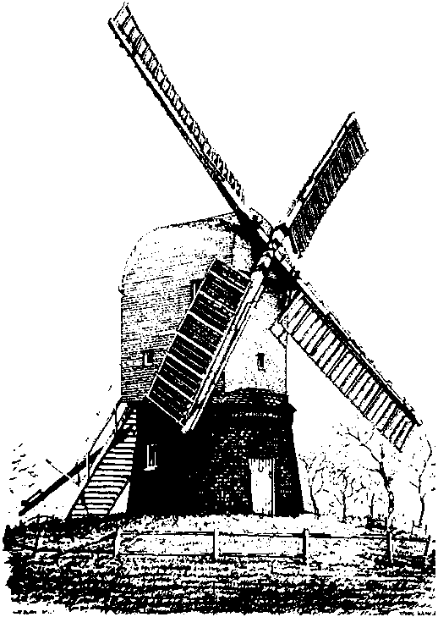
Wrawby St Mary’s C of E Primary School
In reading we will …
read a selection of books including The Three Little Wolves and the Big Bad Pig by Eugene Trivizas, The Very Hungry Caterpillar by Eric Carle and Oi Frog by Kes Grey.

Maths Skills
Reception
- Counting – counting to 10 and back again, counting out up to 10 from a larger group, recognising the numerals to 10, ordering numbers to 10
- Comparison – more, less and the same
- Time – days of the week, including weekends
- Composition – number bonds to 5; composition of numbers to 7
Year 1
- Place value – numbers to 50
- Counting – count to and across 100, forwards and backwards, beginning at any number; Count in 2’s and 10’s to 100.
- Calculation – Addition and subtraction within 20, using the addition and subtraction signs and finding missing numbers.
- Mass/weight – comparing; measuring using non-standard units

All of the above will be taught and learned through an engaging combination of games, challenges and investigations, both independently and with their peers.

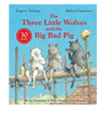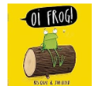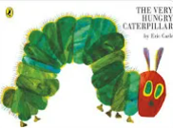

Phonics/Read Write Inc
The children will continue their Read Write Inc. journey, learning and progressing at their own level. Your child will bring home a RWInc reading book and a reading for pleasure book each week.
To help your child, please encourage your child to read their reading book to you daily, where possible. This will help build up their phonic knowledge and fluency. Also discuss with your child what they have read ensuring they have a secure understanding of the text. Please log children’s reading on the Learning with parents app. The reading for pleasure book may be read by yourselves with your child.

Literacy Skills
This term our class book focus will be Paddington. We will all create story maps and retell the story orally.

The Year 1 children will write the opening of the story in their own words and a non-chronological report about transport. This links to their previous learning in Geography. The GaPS skills they will learn include writing words ending in -s and -es, -er and -est’ and they will extend their sentences using ‘and’.

The Reception children will write short sentences using words that match their phonic ability. They will use finger spaces.

The class will perform some poetry from the book All aboard the London Bus.
Spellings
Year 1 children will learn a new spelling pattern each week. Children will learn ten spellings a week. These will be taught in school. A copy of spellings can be found on the school website under Class 1.

Geography
Our big question
for this half term
in Geography is:
How can you get
to London ?

We will learn about different types of transport that can take us from one place to another. We will identify routes and places on a map and will describe a journey from one place to another.

Enquiry questions;
- Can I explain how I get to school?
- Can I name and talk about different forms of transport?
- Can I find places on a simple map?

Computing
This term children will learn about data and information. They will label groups of objects sort them into different groups, based on the properties they choose.

Science
In Science this term pupils will explore Everyday Materials. They will name and investigate the materials which make up the world around them. They will explore their properties and plan tests to challenge their scientific thinking.
Art
Ceramics - the children will explore the characteristics of clay - they will be introduced to coiling for shaping, and ‘slip and score’ method of joining two pieces of clay together in order to creatively make a 3D model.

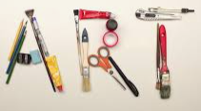

PE
The children will have their PE lessons on Mondays and Fridays. This half-term we will be covering gymnastics and dance.

Music
The children will develop their rhythm and pulse knowledge using their voices and percussion instruments.


RE
This term, we will work towards answering the key question ‘Which stories are special to different people?’ with a focus on Christian and Muslim worldviews.

