Apple and sultana crumble

Ingredients
Complexity: low-medium
100g plain flour
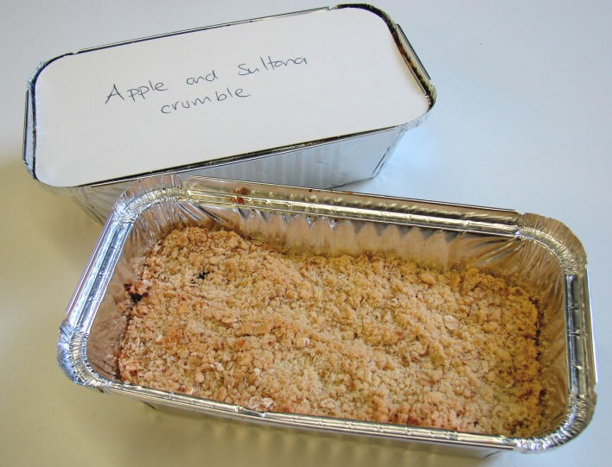
50g butter or baking fat/block
50g oats
25g sugar
2 eating apples
50g sultanas

Equipment
Weighing scales, mixing bowl, wooden spoon, chopping board, knife, ovenproof dish or foil tray, baking tray.

Method
- Preheat oven to 190°C or gas mark 5.
- Rub the fat into the flour until it resembles breadcrumbs.
- Stir in the oats and sugar.
- Cut the apples into quarters and remove the core. Slice thinly.
- Arrange the apple slices in an oven proof/foil tray dish on a baking tray, and then add the sultanas.
- Sprinkle the crumble topping over the apple slices.
- Bake for 25 – 30 minutes, until the apples are soft and the crumble is golden.

Top tips
- Add a little water to the apples.
- Be creative and experiment with other fruits, such as blackberries, apricots, raspberries, peaches, nectarines, plums or pears.
- You may wish to use canned apple or another type of canned or dried fruit.
- Try using wholemeal flour for the crumble topping or use muesli instead of oats.

Food skills
- Weigh.
- Core.
- Cut and slice.
- Rub in.
- Mix and stir.
- Bake.

This recipe is from the original Licence to Cook programme and is provided under the Open Government Licence.

