Autumn term 1 2026 Class 2
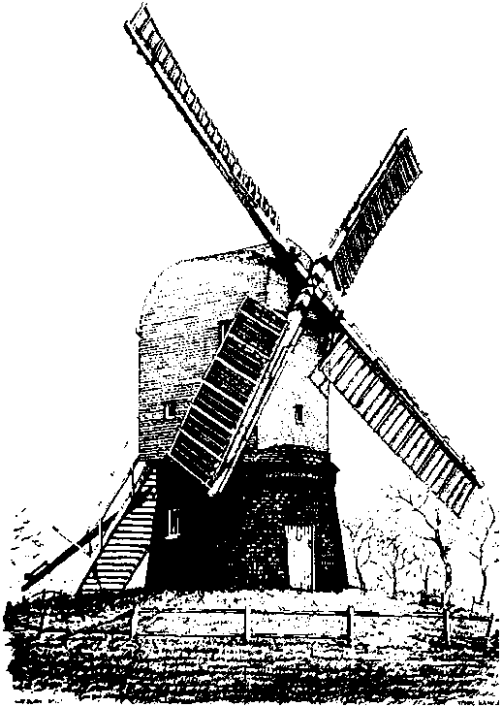
Wrawby St Mary’s C of E Primary School
In reading we will….
Our daily story time book will be a selection of books including: Man on the Moon by Simon Bartam and Dougal’s Deep sea adventure by Simon Bartam
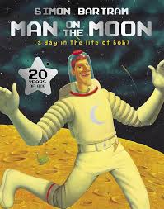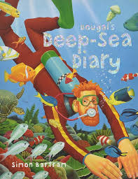

Maths Skills
This half term in maths we will learn:
Time- To know the number of hours in a day, use vocabulary such as o’clock, morning, afternoon, noon and midnight, know the number of days in each month, year and leap year. Know the number of minutes in an hour, seconds in a minute, tell the time to quarter past the hour and to compare time.
Number and place value- read and write numbers to at least 100 in numerals, count in multiples of 100, read, write, compare and order numbers up to 1000, find 10 or 100 more or less than a given number.
Number- Addition and subtraction- recall and use addition facts to 20 fluently, show addition can be done in any order, show subtraction can be done in any order but you will get a different answer, add and subtract numbers mentally including a three-digit number and ones, tens and hundreds.

Reading
Our reading lessons will focus on developing fluency and the pace of our reading, we will use our phonics skills to help us to decode and blend unknown words. In addition, we will be working on our understanding of what we have read through developing comprehension skills. We will be learning new vocabulary that links to our weekly texts. We will be introduced to questioning skills this year and this term our focus will be retrieval questions. We will be taught how to read and interpret the question, locate the answer in the text and how to record the answer to the question.

Literacy Skills
Our first piece of writing this half term, is a narrative based on the story ‘Man on the moon’. The children will rewrite a new adventure for Bob, where something happens on the moon which is a problem that needs solving.
Our second piece of writing is a diary entry, the children will be writing a diary entry based on the story of Dougal’s Deep Sea Diary. Children will be writing their Diary entry based on Dougal’s next adventure.
Science Year 3
The children will learn about Magnets and friction. We will carry out investigations on how objects move on different surfaces and observe how magnets attract or repel each other.

Geography
This term, we consider the question ‘How is our community different from others?’
Children will make comparisons about villages, towns and cities. We will be able to explore and identify the key feature of Cleethorpes (resort) and Immingham (port) and the difference between them. We will begin to understand compass point in between north, east, south and west. This will be followed by planning a journey to different points of interests in Cleethorpes. Finally, we will compare the similarities and differences of Wrawby and Cleethorpes.

Computing
The children will explore creating media. They will look at digital photography where they will be able to link it to our Art unit on self portraits.

Science Year 2 This term, the children will learn about:
Living things and their habitats.
We will carry out a wildlife survey in our school grounds and look at the suitability of habitats for living things.

RE
This term our learning question is ‘what is my duty, how do I know and why does it matter?’ Sikh worldviews.
Music
The children will be taught by Miss Oliver who will teach them songs and how to play instruments.

Art
This term we are working on sketching skills. We will take inspiration from the work of Vincent Van Gogh.
PE
The children will have PE lessons on Mondays and Fridays. We will be learning about different invasion games and develop our athletics skills.

